# **Results**

First of all, calculations of mean scores for both sets of dimensions were computed for each sample that had at least 20 responses (Central, North-Western, Southern, Volga, Ural, and Siberian federal districts) and appear in Table 3 and Table 4.

|  |  |  |  |  |  |  |  |  |  |  |  |
| --- | --- | --- | --- | --- | --- | --- | --- | --- | --- | --- | --- |
| Table 3. |  | | | Central FD | North-western FD | Southern FD | Volga FD | | Ural FD | | Siberian FD |
| Mean scores for the LBDQ dimensions for the samples | | Representation | | 3.58 | 3.70 | 3.81 | 3.82 | | 3.77 | | 3.67 |
| Demand Reconciliation | | 3.49 | 3.91 | 4.00 | 3.61 | | 3.75 | | 3.74 |
| Tolerance of Uncertainty | | 3.32 | 3.32 | 3.32 | 3.32 | | 3.32 | | 3.32 |
| Persuasiveness | | 3.82 | 3.82 | 3.82 | 3.82 | | 3.82 | | 3.82 |
| Initiation of Structure | | 3.86 | 3.86 | 3.86 | 3.86 | | 3.86 | | 3.86 |
| Tolerance of Freedom | | 3.60 | 3.60 | 3.60 | 3.60 | | 3.60 | | 3.60 |
| Role Assumption | | 3.39 | 3.39 | 3.39 | 3.39 | | 3.39 | | 3.39 |
| Consideration | | 3.65 | 3.77 | 3.87 | 3.76 | | 3.83 | | 3.86 |
| Production Emphasis | | 3.65 | 3.56 | 3.73 | 3.69 | | 3.71 | | 3.67 |
| Prediction Accuracy | | 3.72 | 3.96 | 3.84 | 3.78 | | 3.94 | | 3.84 |
| Integration | | 4.02 | 4.12 | 4.41 | 4.11 | | 4.27 | | 4.10 |
| Superior Orientation | | 3.84 | 3.98 | 3.90 | 3.91 | | 3.89 | | 3.78 |
|  | |  |  |  |  | |  | |  |
|  | |  |  |  |  | |  | |  |
|  | Note(s): (Range: maximum 5, minimum 1) | | | | |  | |  | |

|  |  |  |  |  |  |  |  |  |
| --- | --- | --- | --- | --- | --- | --- | --- | --- |
| Table 4. |  | | Central FD | North Western FD | Southern FD | Volga FD | Ural FD | Siberian FD |
| Means scores for Hofstede’s Power Distance for the samples | | Power Distance | 39.49 | 38.60 | 32.17 | 37.03 | 40.00 | 44.39 |
| Individualism | 12.41 | 53.20 | 19.78 | 36.19 | 31.61 | 39.24 |
| Masculinity | 5.32 | -2.80 | 4.57 | 3.56 | 0.00 | 2.12 |
| Uncertainty Avoidance | -11.52 | -4.80 | -4.78 | -12.97 | -5.65 | 1.21 |
| Long-Term Orientation | 1.08 | -8.40 | 13.91 | 3.05 | 16.61 | 15.15 |
| Indulgence | 3.86 | 18.20 | 9.13 | 9.66 | 16.13 | 33.03 |
| Monumentalism | 27.22 | 44.60 | 57.83 | 38.05 | 67.10 | 31.21 |

Note(s): (raw, uncentered data was used, hence the negative values in some dimensions and samples)

To verify the relationship between the two concepts, the Pearson, Spearman as well as linear regression correlations were first employed to assess the relationship between the aggregated sample means of individuals in all federal districts between the two sets of dimensions. Thus, the following results were obtained (Table 5 and Table 6):

|  |  |  |  |  |  |  |  |  |  |  |  |  |  |
| --- | --- | --- | --- | --- | --- | --- | --- | --- | --- | --- | --- | --- | --- |
| Table 5. | |  | | Federal District | | | Dimension | Method | | | Corr. | | P-value |
| Pearson and Spearman Correlation between means of individuals of Hofstede’s Power Distance and dimensions of Tolerance of Freedom and Consideration in all Federal Districts | | | | Central | | | Tolerance of Freedom | Pearson’s r | | | -0.112 | | 0.421 |
| Spearman’s rho | | | -0.144 | | 0.300 |
| Consideration | Pearson’s r | | | 0.050 | | 0.714 |
| Spearman’s rho | | | 0.097 | | 0.487 |
|  |  | | |  | |  |
|  |  | | |  | |  |
| North-Western | | | Tolerance of Freedom | Pearson’s r | | | -0.090 | | 0.672 |
| Spearman’s rho | | | 0.029 | | 0.891 |
| Consideration | Pearson’s r | | | 0.059 | | 0.781 |
| Spearman’s rho | | | 0.041 | | 0.846 |
|  |  | | | | Volga | Tolerance of Freedom | | | Pearson’s r | -0.084 | | 0.599 | | |
|  | | | | Spearman’s rho | 0.032 | | 0.838 | | |
|  | | | | Consideration | | | Pearson’s r | -0.075 | | 0.640 | | |
|  | | | | Spearman’s rho | 0.051 | | 0.751 | | |
|  | | | | Siberian | Tolerance of Freedom | | | Pearson’s r | 0.161 | | 0.206 | | |
|  | | | | Spearman’s rho | 0.090 | | 0.478 | | |
|  | | | | Consideration | | | Pearson’s r | 0.033 | | 0.792 | | |
|  | | | | Spearman’s rho | -0.014 | | 0.907 | | |
|  | | |  | | |

|  |  |  |  |  |  |  |  |  |  |  |
| --- | --- | --- | --- | --- | --- | --- | --- | --- | --- | --- |
| Table 6. |  | Federal District | Dimension | | R | R-Square. | Std. Error of the Estimate | P-value | Slope | Intercept |
| Linear regression between means of individuals of Hofstede’s Power Distance and dimensions of Tolerance of Freedom and Consideration in all Federal Districts | | Central | Tolerance of Freedom | | -0.112 | 0.012 | 13.239 | 0.421 | -10.734 | 85.120 |
| Consideration | | 0.050 | 0.002 | 14.400 | 0.714 | 5.299 | 25.829 |
| North-Western | Tolerance of Freedom | | -0.090 | 0.008 | 24.821 | 0.672 | -10.626 | 70.918 |
| Consideration | | 0.059 | 0.003 | 20.298 | 0.781 | 5.705 | 5.608 |
| Volga | Tolerance of Freedom | -0.084 | | 0.007 | 14.128 | 0.599 | -7.485 | 67.034 |
| Consideration | -0.075 | | 0.005 | 14.026 | 0.640 | -6.610 | 65.756 |
| Siberian | Tolerance of Freedom | 0.161 | | 0.025 | 14.368 | 0.206 | 18.327 | -36.761 |
| Consideration | 0.033 | | 0.001 | 15.537 | 0.792 | 4.112 | 16.424 |
| **Note(s): Predictors (Constant): Power Distance** | | | | | |

Large P-values show that correlations at the individual level are not significant. Such results support the idea of Hofstede, who stated that VSM is not for comparing individuals. Hence, for further investigation of the issue, correlations were separately performed on the mean values on the regional level of four federal districts (Central, North-Western, Volga, Siberian):

|  |  |  |  |  |  |
| --- | --- | --- | --- | --- | --- |
| Table 7. |  | |  | | Power Distance |
| Pearson Correlation between means of Hofstede’s Power Distance and dimensions of Tolerance of Freedom and Consideration in four Federal Districts | | Tolerance of Freedom | Pearson’s r | | -0.864 |
| P-value | | 0.135 |
| Consideration | Pearson’s r | | -0.995 |
| P-value | | 0.004 |
|  | |

In both cases, there is a significant negative correlation between dimensions of preferred leader behavior and Power Distance (r = -0.864 and r = -0.995). That is, the higher the Power Distance index, the lower the Tolerance of Freedom and Consideration scores. Despite this, in the case of Tolerance of Freedom, the P-value is greater than 0.05% and equals 0.13%, meaning that it is not significant and there is a 13% chance that the correlation is random. This can be justified by the limited set of federal districts studied as well as a relatively small number of people surveyed. As for the Consideration, the resultant P-value is statistically significant since it is greater than 0.05.

Also, the Spearman correlation was used to investigate the issue (Table 8):

|  |  |  |  |  |
| --- | --- | --- | --- | --- |
| Table 8. |  | |  | Power Distance |
| Spearman Correlations between means of Hofstede’s Power Distance and dimensions of Tolerance of Freedom and Consideration in four Federal Districts | | Tolerance of Freedom | Spearman’s rho | -0.799 |
| P-value | 0.2 |
| Consideration | Spearman’s rho | -1.0 |
| P-value | 0.0 |
|  |

As with Pearson correlation, there were strong negative correlations between variables as well as a large P-value (0.2) in the relationship between the Tolerance of Freedom and Power distance indicating its insignificance. However, a very low P-value in case of Consideration (0.0) showed the validity of the correlation, which confirms the results obtained earlier.

Finally, linear regression analysis was utilized for the samples (Table 9)

|  |  |  |  |  |  |  |  |  |  |  |  |
| --- | --- | --- | --- | --- | --- | --- | --- | --- | --- | --- | --- |
| Table 9. |  | | R | R-Square | Std. Error of the Estimate | | P-value | | Slope | | Intercept |
| Regression model for the overall sample of four Federal Districts for Hofstede’s Power Distance and dimensions of Tolerance of Freedom and Consideration | | Tolerance of Freedom | -0.864 | 0.748 | | 17.453 | 0.135 | | -42.531 | | 196.63 |
| Consideration | -0.995 | 0.990 | | 2.914 | 0.004 | | -42.446 | | 205.112 |
| Note(s): Predictors (Constant): Power Distance. | | | | | |  | |  |  |

Regression coefficients indicate a very strong negative relationships (R = -0.864 and R = -0.995), while the determination coefficients show (R2 = 0.748 and R2 = 0.990) that cultural dimension of Power Distance accounts for 74.8 % and 99% of the variance in the Tolerance of Freedom and Consideration relationships accordingly. Once again, the P-value in the relationship between Tolerance of Freedom and Power Distance is not statistically significant (P-value > 0.05), thus, it means that the identified correlation is due to chance and does not support the idea being investigated. The regression model also confirms the non-randomness of the previously obtained values for the Consideration and Power Distance relationships, in particular the P-value (0.004), which is less than 0.05 and is an indicator of significance and it gives evidence to the existing relation between the two. Furthermore, the standard error of the estimate in case of Consideration is much lower than in Tolerance of Freedom, which means that the overall accuracy of the former is higher due to the lower variability around the estimated regression line.

In addition, a visualization of the regression models was performed to better understand the results (figure 4 and figure 5)

Figure. 4

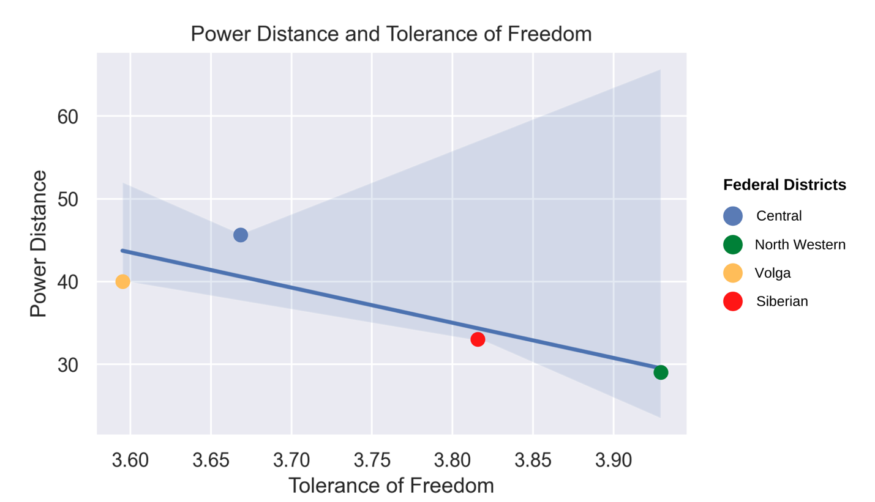

Figure. 5

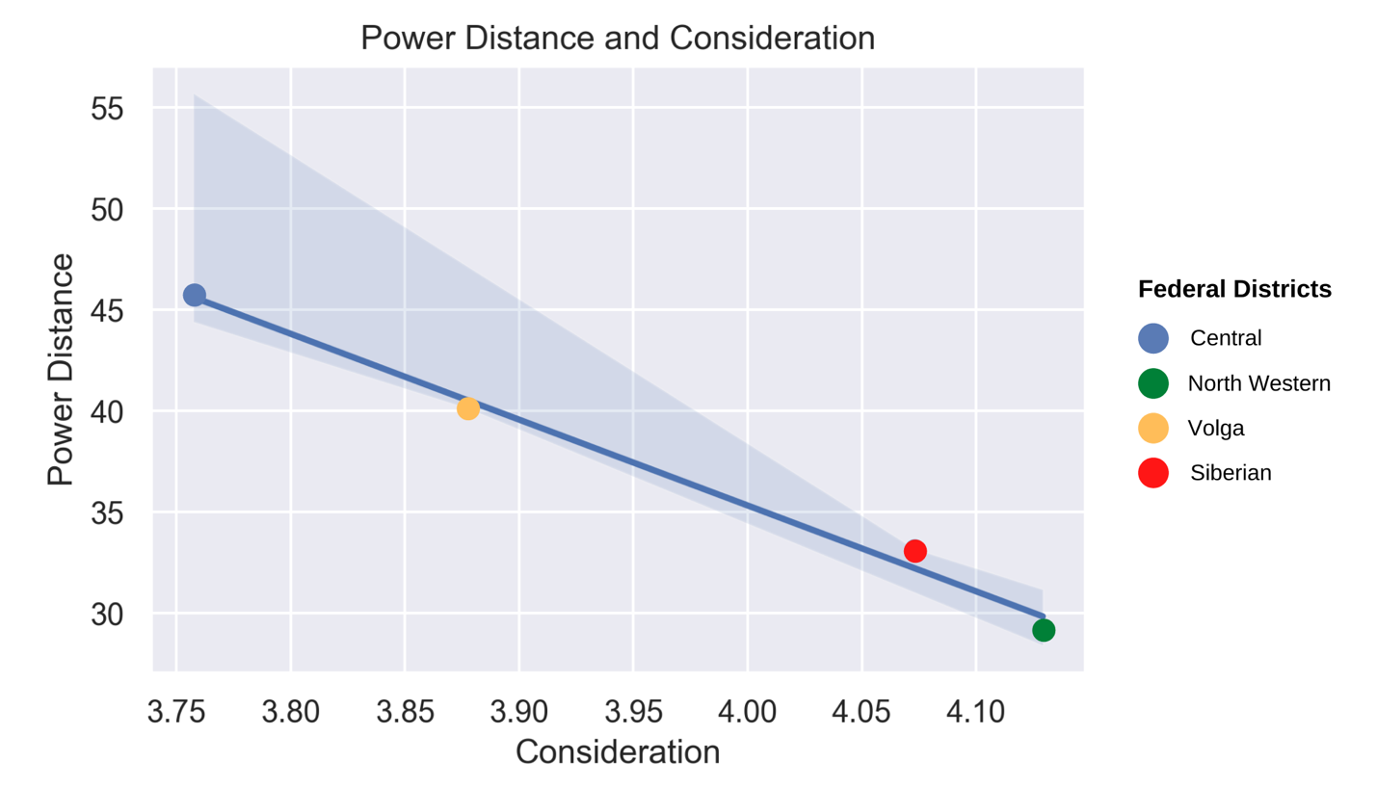

As stated earlier, due to the nature of the samples, namely that not all federal districts were chosen for analysis due to the small number of responses received, there is a possibility of randomness in the results obtained. Nevertheless, they represent an attempt to assess the relationship between cultural values and preferences for leader behavior in different regions of Russia.

Also, it is necessary to indicate the obtained results among the whole sample for Russia, not just the selected four federal districts as the focus of the analysis (Table 10):

|  |  |  |  |  |  |
| --- | --- | --- | --- | --- | --- |
| Table 10. |  | | Power Distance | Tolerance of Freedom | Consideration |
| Mean scores for Hofstede’s Power Distance and dimensions of Tolerance of Freedom and Consideration in overall sample in Russia | | Russia | 37.9 | 3.73 | 3.95 |

Judging by the overall scores of leader behavior dimensions (Tolerance of Freedom mean = 3.7, Consideration mean = 3.95), it can be noted that they exceeded half of the range of 1 to 5, which means that for the most part, there is a tendency towards freer and less hierarchical attitudes in the preference for the leader behavior by employees. As for Power Distance index, the obtained result, 38, is less than half of the range (0 – 100), suggesting that there is a tendency for Russia to have small Power Distance.